

PYTHON PROGRAMMING
MINI PROJECT REPORT
PROJECT TITLE
Grade Calculator
Using Conditional Constructs

SUBMITTED BY
Vedika Bodke  Roll Number: 38 |  | Srushti Karande  Roll Number: 31

CLASS / SEMESTER | SY-C / III
SUBMITTED TO | Ashish Mishra
ACADEMIC YEAR | 2026 – 2027

TABLE OF CONTENTS PAGE
01 Introduction 2
02 Problem Statement 2
03 Objectives 2
04 Methodology 3
05 Python Concepts Used 3
06 Source Code and Implementation 3
07 Program Execution and Output 4
08 Conclusion 4
09 GitHub Repository 5

01 INTRODUCTION
A Grade Calculator is a simple Python-based application designed to calculate a student’s total marks, percentage, and corresponding grade based on marks obtained in examinations. It helps automate the grading process and reduces the possibility of manual calculation errors.
This project uses conditional constructs in Python, such as if, elif, and else, to evaluate a student’s performance according to predefined grading criteria. The program accepts marks as input, calculates the percentage, and displays the appropriate grade.
The project demonstrates the practical application of basic programming concepts and provides an introduction to developing simple, logical, and user-friendly applications using Python.

02 PROBLEM STATEMENT
Calculating percentages and assigning grades manually for students can be time-consuming and may lead to calculation errors. A simple automated system is required to evaluate students’ academic performance based on their marks.
The objective of this project is to develop a Python program that accepts marks obtained by a student, calculates the percentage, and assigns a grade using conditional constructs. The program should also validate the entered marks and display the final result clearly.
The grading criteria are predefined and can be modified according to the requirements of an educational institution. The scale used in this project is shown below.
A+ | A | B | C | D | F
90% and above | 80% – 89% | 70% – 79% | 60% – 69% | 35% – 59% | Below 35%

03 OBJECTIVES
The main objectives of the Grade Calculator project are:
- To develop a simple grade calculation system using Python.
- To calculate the percentage of marks obtained by a student.
- To assign grades automatically using conditional constructs.
- To understand the implementation of if, elif, and else statements.
- To validate user input and prevent invalid marks from being processed.
- To reduce manual calculation errors and save time.
- To display the student’s result in a clear and understandable format.

04 METHODOLOGY

1 | The program asks the user to enter marks obtained in five subjects.
2 | It checks whether the marks entered are within the valid range of 0 to 100.
3 | It calculates the total marks and percentage.
4 | It uses conditional statements to determine the grade.
5 | If any subject has marks below the passing mark, the student is declared to have failed.
6 | Finally, it displays the total marks, percentage, and grade.

05 PYTHON CONCEPTS USED
This section explains the Python concepts that are used in the project.
CONCEPT | DESCRIPTION
Variables | Store subject marks, total marks, percentage, and grade.
Input function | input() accepts marks entered by the user.
Type conversion | float() converts the entered marks into numerical values.
Arithmetic operators | Calculate the total and percentage.
Conditional constructs | if, elif, and else determine the grade.
Logical operators | or checks whether any subject has marks below the passing mark.
Lists | Store marks for multiple subjects.
Loops | for repeats the input process for each subject.
Output function | print() displays the final result.

06 SOURCE CODE AND IMPLEMENTATION
# Grade Calculator for 5 Subjects
total = 0

for i in range(1, 6):
subject = input("Enter subject name: ")
marks = int(input("Enter marks out of 100: "))
total = total + marks

percentage = total / 5

print("\nTotal Marks:", total, "/ 500")
print("Percentage:", percentage, "%")

if percentage >= 90:
print("Grade: A+")
elif percentage >= 80:
print("Grade: A")
elif percentage >= 70:
print("Grade: B")
elif percentage >= 60:
print("Grade: C")
elif percentage >= 35:
print("Grade: D")
else:
print("Grade: F")

07 PROGRAM EXECUTION AND OUTPUT
The program was executed with two different sets of marks. The terminal output below shows the total, percentage, and the grade assigned in each case.
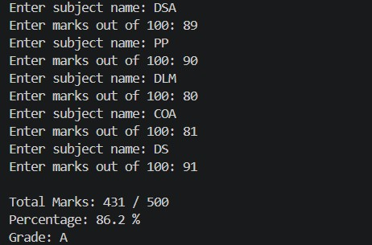  Figure 1: Sample run — 431 / 500, 86.2%, Grade A |  | 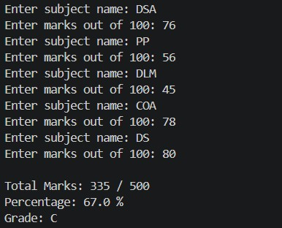  Figure 2: Sample run — 335 / 500, 67.0%, Grade C

08 CONCLUSION
The Grade Calculator Using Conditional Constructs project demonstrates the practical application of Python programming in automating student grade evaluation. The program accepts marks, validates the input, calculates the total and percentage, and assigns grades using conditional statements.
This project helped in understanding fundamental programming concepts such as variables, lists, loops, arithmetic operators, logical operators, and decision-making statements. It also demonstrates how a simple program can reduce manual effort and improve the accuracy of calculations.
In the future, the project can be enhanced by adding a graphical user interface, student details, multiple student records, file storage, and report generation features.

09 GITHUB REPOSITORY
The repository contains the project source code.
ITEM | DETAILS
GitHub Username | Riya18code
Repository Name | miniproject.py
Repository URL | https://github.com/Riya18code/Python_Code

